1. Start mysql and use retail database

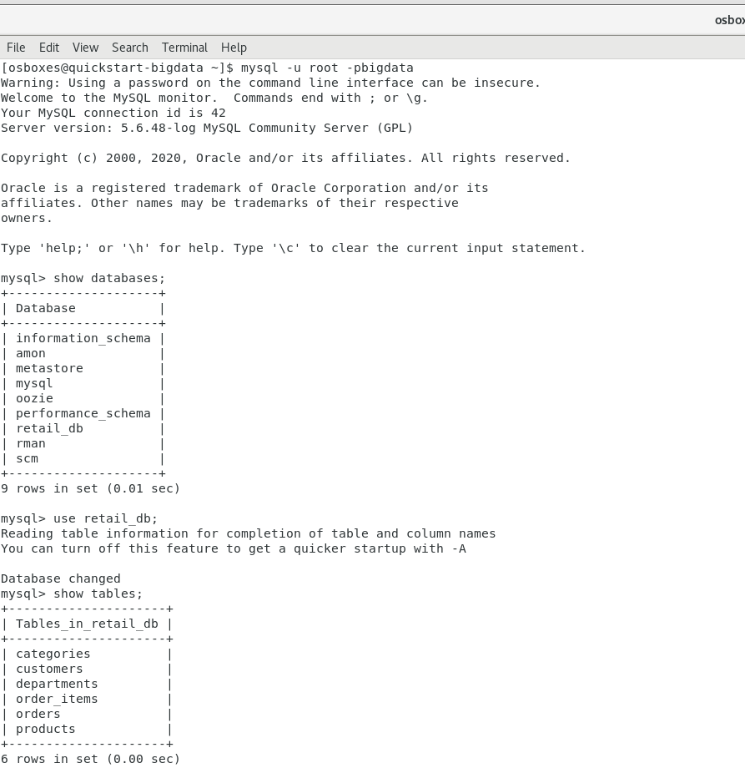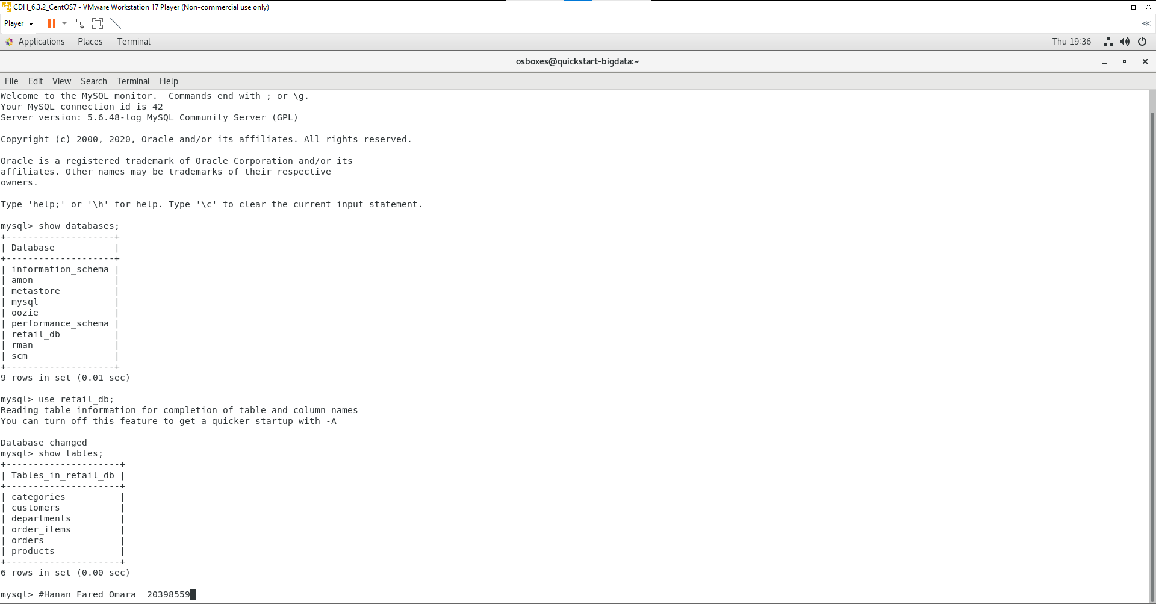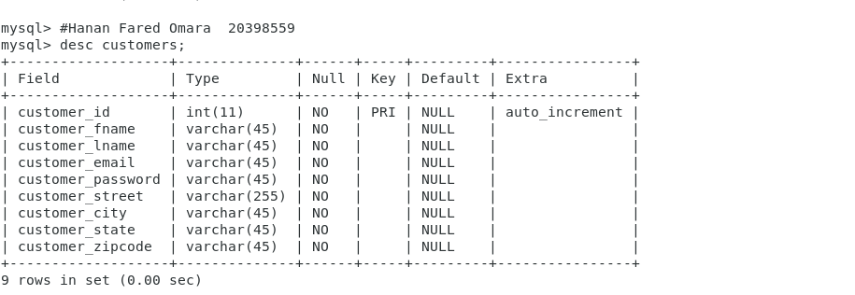

1. Create Customers table

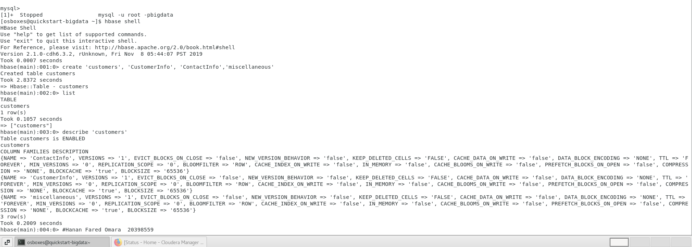

1. From the given MYSQL database named 'retail_db' within VM, import the data of Customers table into the Hbase Customers table.

("customer_id" field should be the row key CustomerInfo column family may contain several keys: customer_fname, customer_lname, customer_email, customer_password)

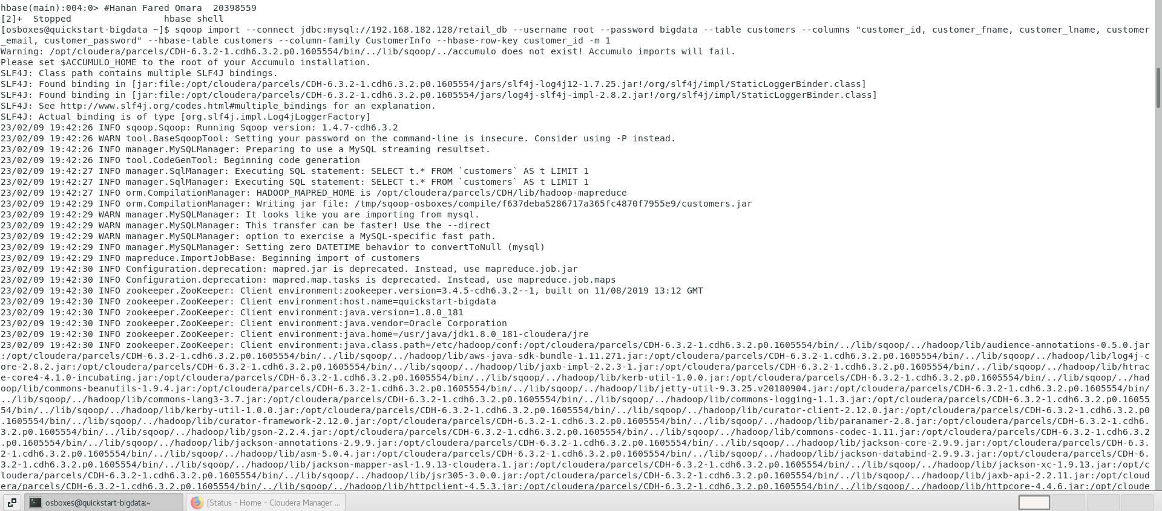

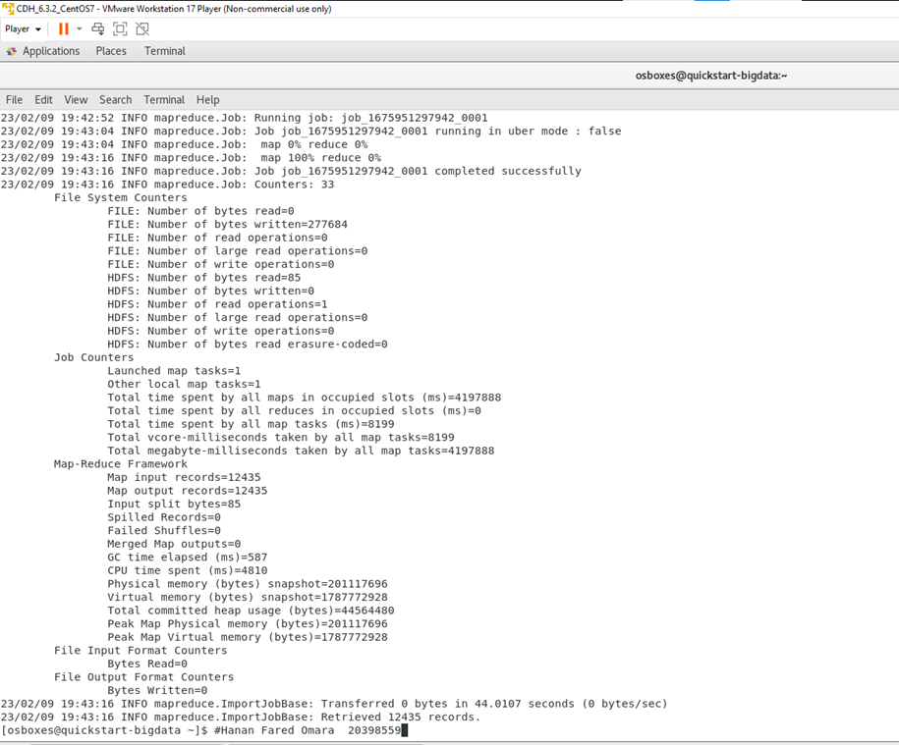

1. ContactInfo column family may contain the following keys and associated values: customer_street, customer_city, customer_state, customer_zip

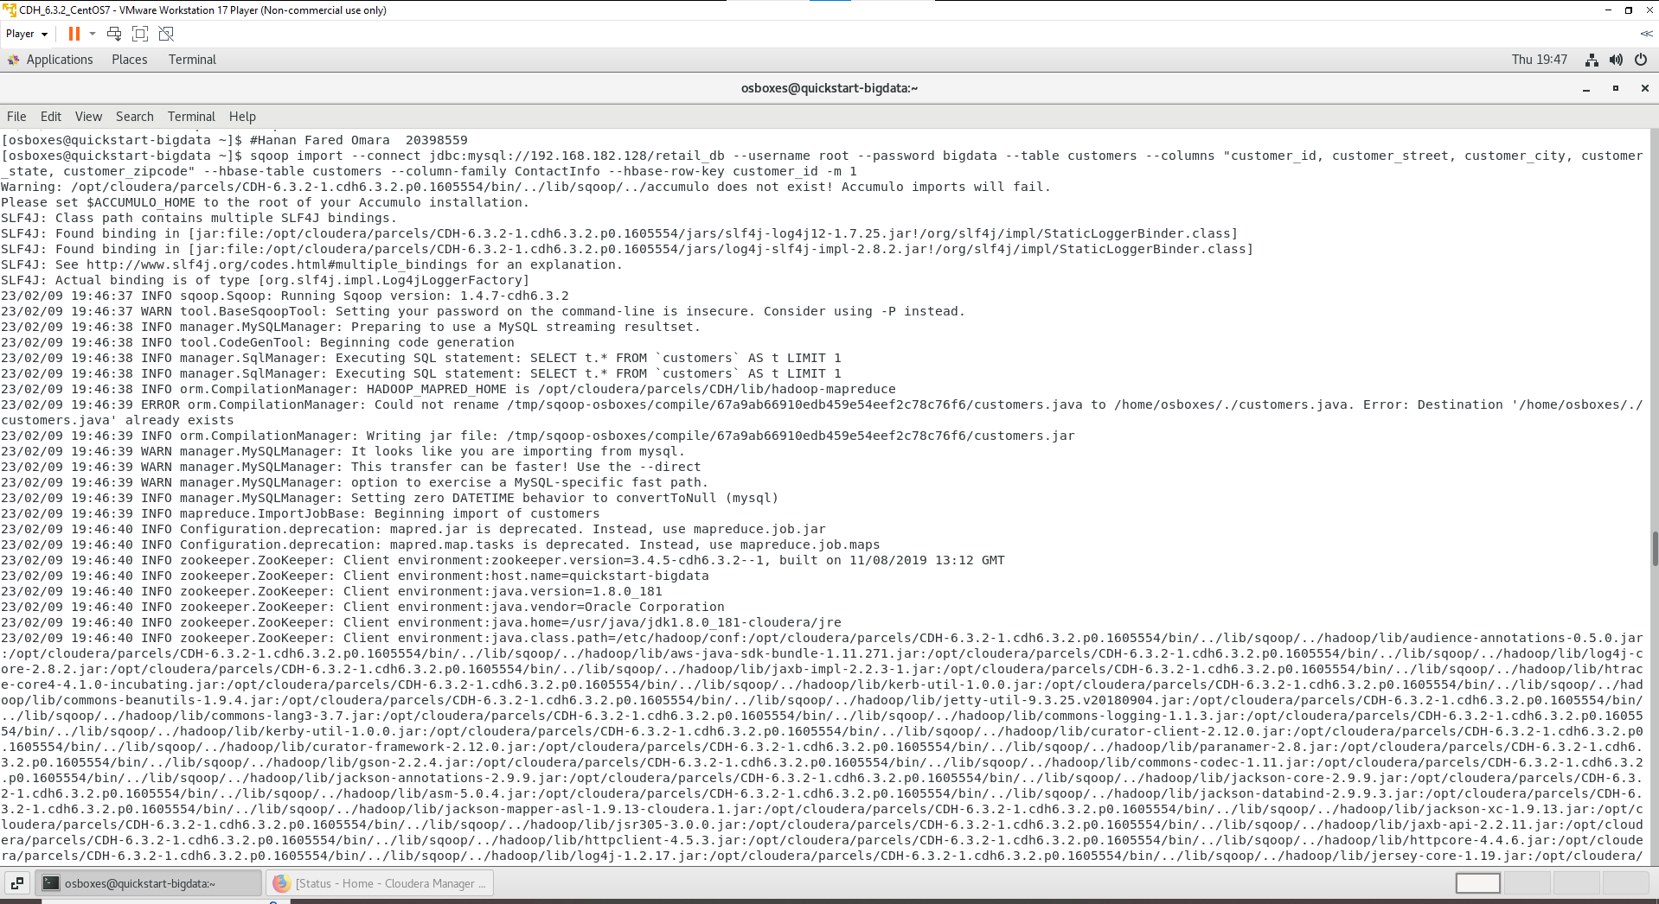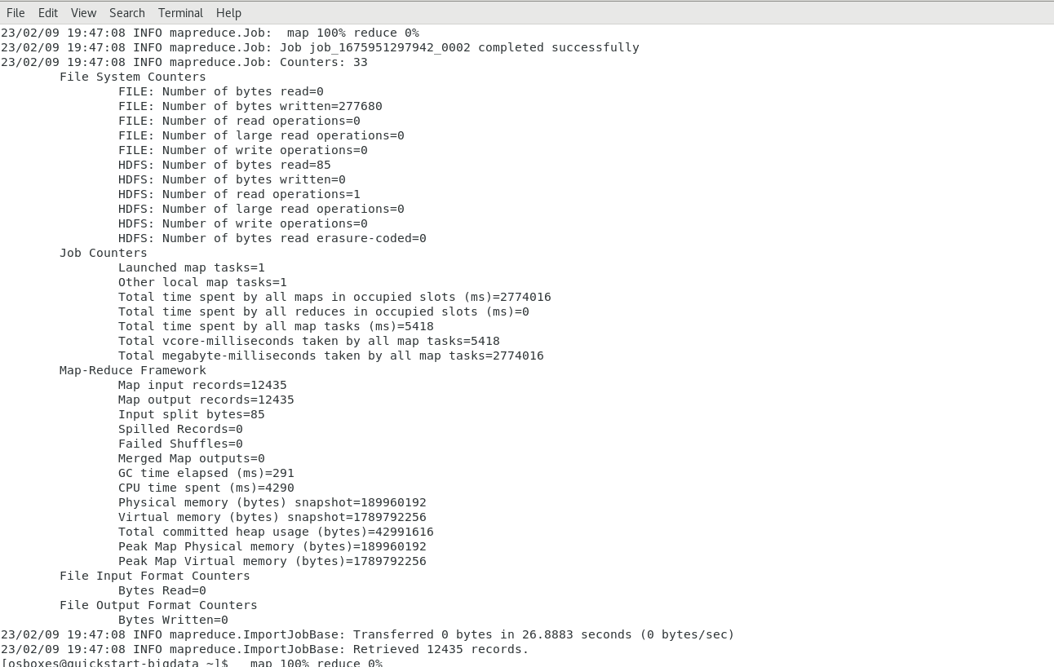

1. A miscellaneous column family should contain the remaining fields.

(( NO remaining fields )) so I don’t write any command for that.

1. Import filters

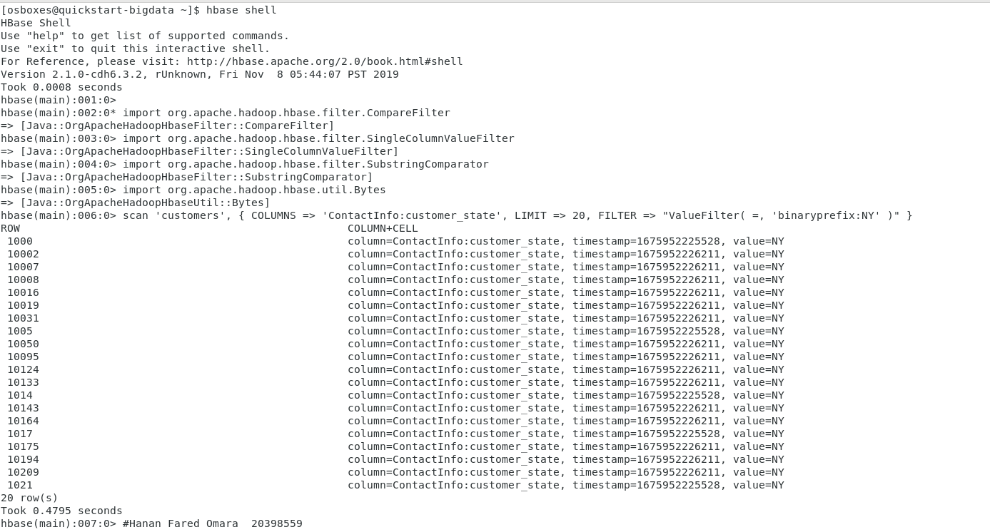

1. List top 20 records of NY and VA state from the Hbase table

NY

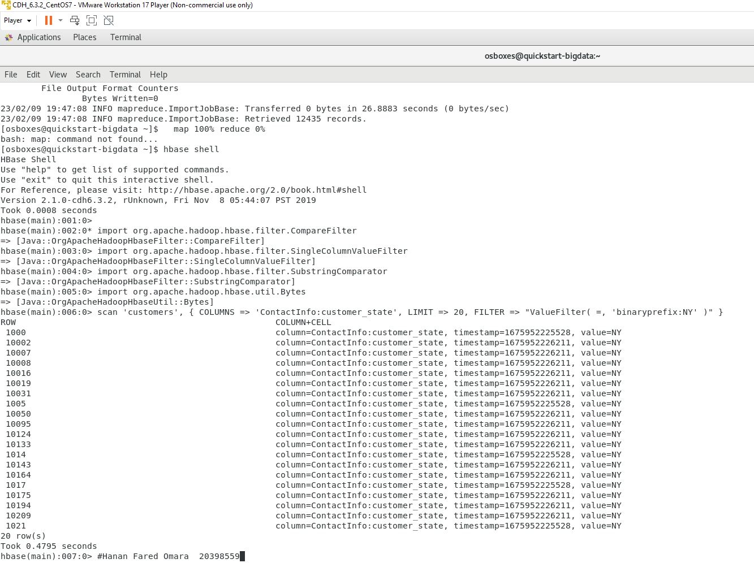

VA

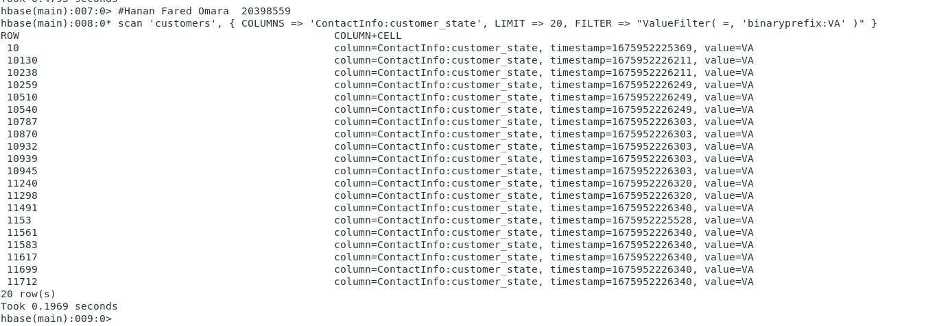

1. Demonstrate the application of two other HBASE commands

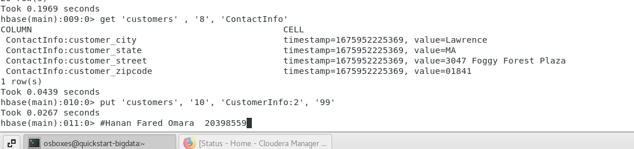

* (get 'customers' , '8', 'ContactInfo') this command to read the data from HBase tables
* (put 'customers', '10', 'CustomerInfo:2', '99') this command to insert rows into a table

**Conclusion**

* In this lab, I used My SQL to manage a database (a retail database), then I presented tables, ran Hbase to create the tables "Customers," "CustomerInfo," and "ContactInfo," and last I imported data into HDFS from external datastores.
* Then, I finally listed the top 20 records for the states of NY and VA from the Hbase table.

**References**

1. <https://dwgeek.com/read-hbase-table-using-hbase-shell-get-command.html/>
2. <https://www.tutorialspoint.com/hbase/hbase_create_data.htm>